Firefox add-in settings
____________________________________________________
- Click on 3 lines icon in top right corner
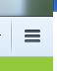
- Click Options
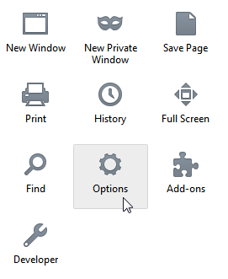
- Click Applications
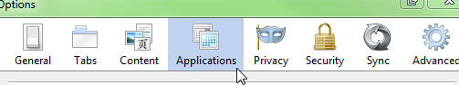

- The following four settings must say Use Adobe Acrobat (in Firefox). To change the setting, click on the dropdown on the right side of the box. Select Use Adobe Acrobat (in Firefox)
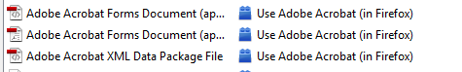
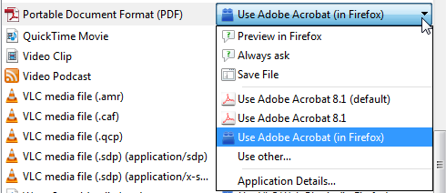
- Click OK

