Infinite Campus: New Look, New Features
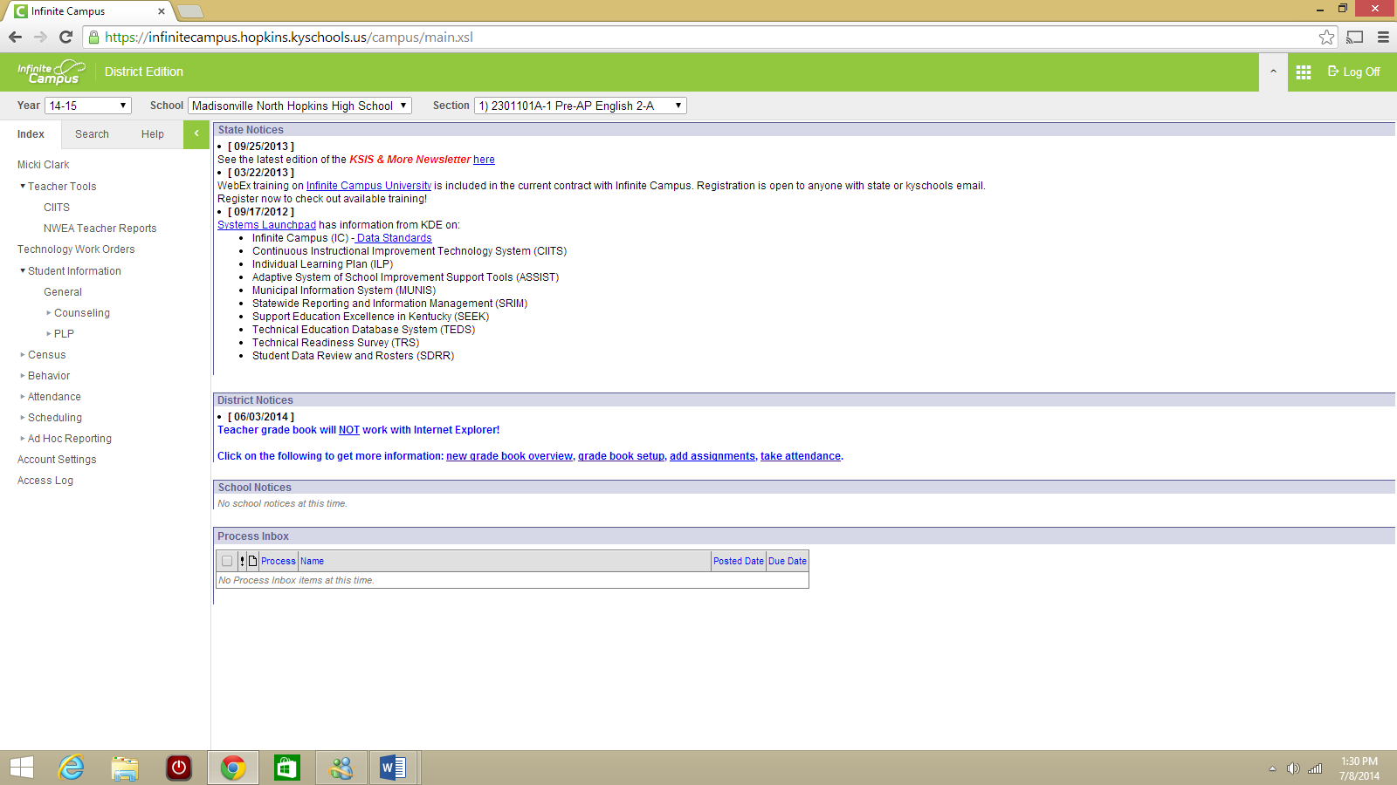
When you first log in to IC, you will see what looks like the traditional IC screen. However, you’ll notice that several of the items you’re used to seeing in your teacher menu are missing.
Let’s first go over the green bar functionality.
In the upper RIGHT corner of your screen, you’ll see this green bar. If you’ll notice the down arrow next to your first class—that’s how you pull the selection menu down out of the green bar:
As you can see, now I can select which section I want to work with.

Infinite Campus: Campus Instruction

- Click on the grid of nine white boxes in the upper right corner.
- Choose “Campus Instruction Beta” from the two options.

- You now have access to the areas you were missing (gradebook and attendance).

Attendance
Attendance is located on the left side of your screen.

Reports & Seating Charts
Here’s where to access some of the areas many of you used on IC in the past:
Seating Charts are accessible from the main sidebar menu. It’s the fifth option down.
If you don’t see the sidebar menu, you may have hidden it. Just click the three black lines to show it:
Reports (Gradebook) has the option to do Grade Book Export, Missing Assignments, Section Summary, Student Summary, and Online Assessment reports.
Reports (Planner) has an option to do your blank spreadsheets.
Reports (Roster) also has a blank spreadsheet option and a print label option.
Finally, Account Settings has some important options for you:
You can choose to start in Campus Instruction (with access to your gradebook and attendance) or Tools. You can also choose to change certain display items, like only showing active students, showing student pictures, or using seating charts to take attendance.

Gradebook
From Campus Instruction Beta (remember, if you don’t see it in the green bar next to your name, click on the nine white squares in the right corner):
- Click on Grade Book at the left.
- Expand the blue SETTINGS tab, indicated by the black arrow in the picture above.
- There are several new options available for you, including filters. We’ll begin with gradebook setup:
- To Create Categories for your grades:
  - Click Categories.
  - In the bottom right corner of the screen that pops up, click Add.
  - For each category, follow this procedure:
    - Title the category (homework, tests, projects)
    - If you plan to weight categories, enter a weight. Weights must total 100%.
    - Sequence determines which category is listed first in your gradebook.
    - Exclude from calculations – I exclude my CIITS test category from calculations. I can always edit an individual test and move it to a category that is graded, but I don’t like them being uploaded and included in the grade until I have checked them for accuracy.
    - Drop lowest score – click if you wish
    - Category Placement – click the box beside each class you wish. If you plan to use the same category for all sections, just click the “term” box in category placement to select them all at once.
    - Grading Task – select term grade.
    - Click Save.
  - Click “add” to repeat this process for every category you wish to create.
  - Click “close” when you are finished.
- To set the Grade Calc Options:
  - Select “In Progress Grade” for Term Grade Only.
  - Select “Numeric” for Grading Scale unless your course is Advanced Placement.

Percent Value versus Points
Assignment 1 | 8/10 | 80%
Assignment 2 | 48/50 | 96%
Assignment 3 | 75/100 | 75%
TOTAL | 131/160 (81.98%) | 83.67%

If you weighted your categories during creation, be sure to click the “weight categories” box. If you wish to calculate on percentage value versus points, click the “Use Score’s % Value”. If you aren’t sure which of those two you’d rather do, a comparison of how the grades work using points versus percentage is provided above.
Click “Save”.

Infinite Campus: Assignment Creation

- Open Campus Instruction Beta (white grid in the upper right corner).
- Select Grade Book.
- Click on the blue Settings bar to expand it.
- Click Assignment List.
- At the bottom right, click “Add Assignment”.
- Type the name and abbreviation of the assignment.
If you are adding an assignment to several sections, enter the date assigned, date due, and sequence in the top boxes. Then, simply click the boxes beside any sections you wish to assign.
- Under Grading Tasks, click the box beside Term Grade.
  - Select the category and add the number of points.
- There are additional places for you to enter information that will be available in the student portal.
- Click “Save” and then click “Close” if you are finished. You can also click “New” to create another assignment.
You can also access the add assignment dialogue from the top of your gradebook:

Infinite Campus: Gradebook Tips

In “Settings” (the blue tab):
- Add color coding for pass/fail on either grades or scores
- Give yourself the save alert prompt
- Use Canned Comments
- Change how assignments are sorted in the gradebook
New Filter Options (in “Settings”):
- Student Group
- Missing Flag
- Failing Grade
- Individual Student
- Due this week
- Due next week
- By category
In “Grade Totals” – when you expand this blue tab, you see the posted, in progress, and category columns. You can hide it by clicking the tab again.
To expand an assignment, click on the chevrons. You can also click on the chevrons beside a student’s score:

This is how you access the flags and comment area for each student:
One helpful new feature for the fill scores/comments is the “Present and Empty”—enter the scores for your missing or odd grades first, and then you can fill the others. Just click “Fill Scores/Comments” at the top of the screen (shown in the upper right of the image above) and it’s available in the dropdown:
If you would like to practice with entering grades, Infinite Campus has a beta you can use. You will not enter the gradebook in the same way, but once you have opened the gradebook, the process should be the same.
http://media.infinitecampus.com/public/learn/Simulation/STP/08/09/05/STP.08.09.05_1314/story.html
Additional videos and simulations to help you:
https://community.infinitecampus.com/kb/display/DOC/Videos+And+Simulations

**Note: There are still a few Infinite Campus functions you’ll need to access from the Tools menu rather than the Instruction Beta. Those include:
- Looking up a student’s schedule
- Adding information to a contact log (Student Information PLP)
- Creating a behavior referral

How to Post In-Progress Grades:
**The name of the task will most likely be different for us; this screen shot is from an IC training document that is used nationwide. Up-to-date instructions will be distributed closer to our first posting window.

Posting Exam Grades:

